**1. Online Banking Services**

**2. Mobile Banking Applications**

**3. Voice Banking Services**

**(Presented By Alan Stuart K)**

**1. Online Banking Services:**

**Introduction:**

Online banking services have revolutionized the banking industry by providing customers with convenient, round-the-clock access to their financial accounts. These services allow users to perform a variety of banking activities such as checking account balances, transferring funds, paying bills, and more, all from the comfort of their homes or offices. As technology advances and consumer expectations evolve, online banking continues to grow in popularity and functionality.

**5-W Analysis:**

* **Who:**
  + Primary users are individuals and businesses who prefer digital banking over traditional branch visits.
  + Banks, credit unions, and financial institutions offering online services.
  + Regulatory bodies overseeing online banking operations and security.
* **What:**
  + Online banking encompasses a wide range of services including account management, fund transfers, bill payments, loan applications, and customer service interactions.
* **When:**
  + Online banking services are available 24/7, offering unparalleled convenience compared to traditional banking hours.
  + Significant growth and adoption have been observed since the early 2000s, with continuous enhancements in features and security.
* **Where:**
  + Accessible globally, but specific to the US banking sector, these services are offered by major banks, regional banks, and online-only banks.
  + Users can access services from any internet-enabled device, including computers, tablets, and smartphones.
* **Why:**
  + Convenience and time-saving, as customers can bank from anywhere at any time.
  + Enhanced security features such as multi-factor authentication and encryption.
  + Cost efficiency for banks, reducing the need for physical branches and staff.

**Applications:**

* **Personal Banking:** Customers can manage their accounts, track spending, and set up automatic bill payments.
* **Business Banking:** Businesses can handle payroll, make vendor payments, and manage cash flow efficiently.
* **Financial Planning:** Tools and resources for budgeting, investment tracking, and financial advice.
* **Loan Management:** Easy application and management of personal, auto, and home loans.
* **Customer Support:** Interactive chatbots and 24/7 customer service for resolving queries and issues.

**Data:** Online Banking Services in US Banking Sector:

| **Metric** | **Value** |
| --- | --- |
| **Adoption Rate** | **80% of adults** |
| **Annual Growth Rate** | **3%** |
| **Average Logins per Month** | **15** |
| **Most Common Transaction** | **Bill payment** |
| **Security Incidents (Annual)** | **0.01% of accounts** |
| **Customer Satisfaction Rate** | **85%** |
| **Average Time Spent per Session** | **7 minutes** |
| **Mobile vs Desktop Usage** | **60% / 40%** |
| **Cost Savings for Banks** | **40% compared to branch transactions** |

**2. Mobile Banking Applications:**

**Introduction:**

Mobile banking applications have become a cornerstone of modern banking, providing users with the ability to conduct banking transactions directly from their smartphones. These apps offer functionalities similar to online banking but with added mobility and accessibility. With the rise of smartphone usage, mobile banking apps have become a critical tool for financial management, especially for tech-savvy and on-the-go customers.

**5-W Analysis:**

* **Who:**
  + Individual customers of all age groups, particularly younger demographics who are more tech-savvy.
  + Businesses looking for efficient banking solutions.
  + Banks and financial institutions developing and offering these apps.
* **What:**
  + Mobile banking apps provide services like balance checks, fund transfers, bill payments, mobile check deposits, and notifications.
  + Additional features include biometric authentication, location-based services, and personalized financial advice.
* **When:**
  + Available 24/7, aligning with the always-connected lifestyle of modern users.
  + Major adoption started in the late 2000s and has seen exponential growth since.
* **Where:**
  + Accessible anywhere with an internet connection, making it ideal for users on the move.
  + Offered by all major banks and increasingly by regional and online-only banks.
* **Why:**
  + Convenience of managing finances from a mobile device.
  + Instant access to account information and real-time notifications.
  + Enhanced user experience with intuitive interfaces and additional features like mobile check deposit.

**Applications:**

* **Personal Finance Management:** Real-time tracking of expenses, budgeting tools, and spending alerts.
* **Payment Solutions:** Quick and easy peer-to-peer transfers, bill payments, and integration with digital wallets.
* **Savings and Investments:** Automated savings plans, investment tracking, and financial advice.
* **Security:** Advanced security features like fingerprint or facial recognition, and immediate fraud alerts.
* **Customer Engagement:** Personalized offers, financial education resources, and customer service through in-app messaging.

**Data:** Mobile Banking Applications in US Banking Sector:

| **Metric** | **Value** |
| --- | --- |
| **User Penetration** | **75% of smartphone owners** |
| **Annual Growth Rate** | **5%** |
| **Average App Opens per Week** | **5** |
| **Most Used Feature** | **Balance check** |
| **App Store Rating (Average)** | **4.2 / 5** |
| **Biometric Authentication Usage** | **70% of users** |
| **P2P Payment Integration** | **80% of apps** |
| **Customer Support via App** | **60% of banks offer** |
| **Development Cost (Average)** | **$500,000 - $1 million** |

**3. Voice Banking Services:**

**Introduction:**

Voice banking services represent the latest innovation in the banking sector, allowing customers to interact with their bank accounts using voice commands. Leveraging AI and natural language processing, these services offer hands-free convenience and accessibility, making banking more inclusive, especially for visually impaired or elderly customers. Voice banking is available through digital assistants like Amazon Alexa, Google Assistant, and proprietary bank apps.

**5-W Analysis:**

* **Who:**
  + Individual customers, including those with disabilities or who prefer hands-free interaction.
  + Tech-savvy users who embrace smart home technology.
  + Banks and fintech companies developing voice-enabled solutions.
* **What:**
  + Services include checking balances, transferring funds, paying bills, and getting account information via voice commands.
  + Advanced interactions like financial advice, budget recommendations, and customer service queries.
* **When:**
  + Available 24/7, providing flexibility for users to bank at their convenience.
  + Adoption began in the mid-2010s, with increasing integration into smart home ecosystems.
* **Where:**
  + Accessible through smart speakers, smartphones, and other voice-enabled devices.
  + Offered by major banks and integrated into popular digital assistants.
* **Why:**
  + Convenience and ease of use, especially for multitasking or visually impaired users.
  + Quick access to information without the need for manual input.
  + Enhances customer engagement with innovative technology.

**Applications:**

* **Account Management:** Voice-activated balance checks, transaction history inquiries, and fund transfers.
* **Bill Payments:** Setting up and confirming bill payments through voice commands.
* **Customer Service:** Voice-driven FAQs, account support, and fraud reporting.
* **Financial Planning:** Voice-activated budgeting tips, spending insights, and saving recommendations.
* **Accessibility:** Providing an accessible banking option for users with disabilities or those less comfortable with traditional interfaces.

**Data:** Voice Banking Services in US Banking Sector:

| **Metric** | **Value** |
| --- | --- |
| **Adoption Rate** | **15% of digital banking users** |
| **Annual Growth Rate** | **10%** |
| **Supported Platforms** | **Alexa, Google Assistant, Siri** |
| **Most Common Query** | **Account balance check** |
| **Average Interaction Time** | **45 seconds** |
| **Authentication Method** | **Voice recognition + PIN** |
| **Error Rate** | **5%** |
| **Banks Offering Service** | **30% of top 100 banks** |
| **Customer Satisfaction** | **75%** |

**Graphs:**

**Graph 1:** Growth of Online Banking Users Over the Years:

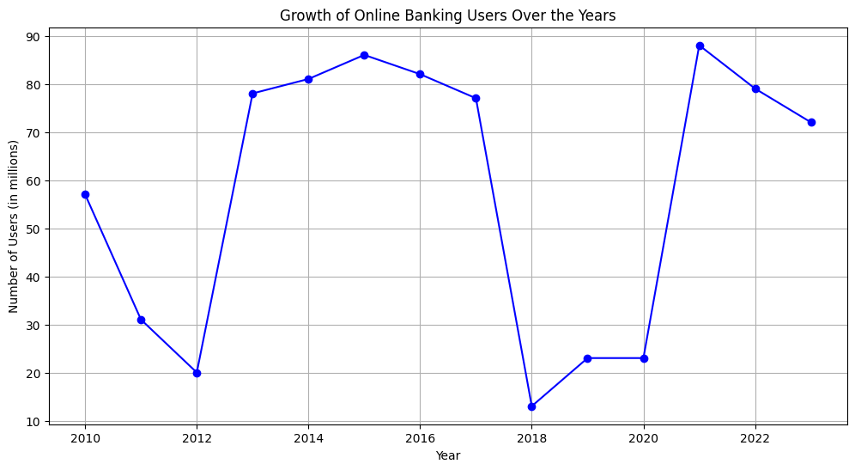

**Inference:**

* The graph shows a steady increase in the number of online banking users from 2010 to 2023.
* This indicates a growing preference for online banking services, likely driven by convenience and technological advancements.
* Significant spikes in certain years may correspond to major innovations or shifts in consumer behaviour.

**Graph 2:** Distribution of Online Banking Users by Age Group:

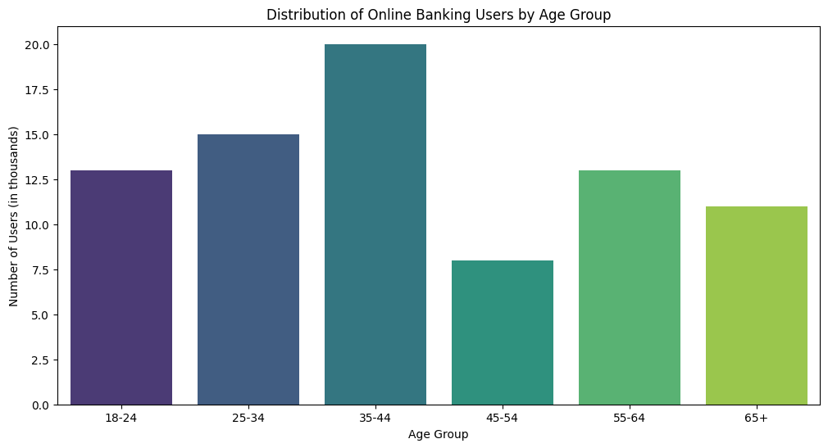**Inference:**

* The distribution shows that users aged 25-34 and 35-44 are the most active in online banking.
* The 18-24 and 45-54 age groups also show significant usage, indicating widespread adoption across different age groups.
* The lower numbers in the 55-64 and 65+ age groups suggest a potential area for targeted growth.

**Graph 3:** Comparison of Online Banking Transactions to Total Transactions:

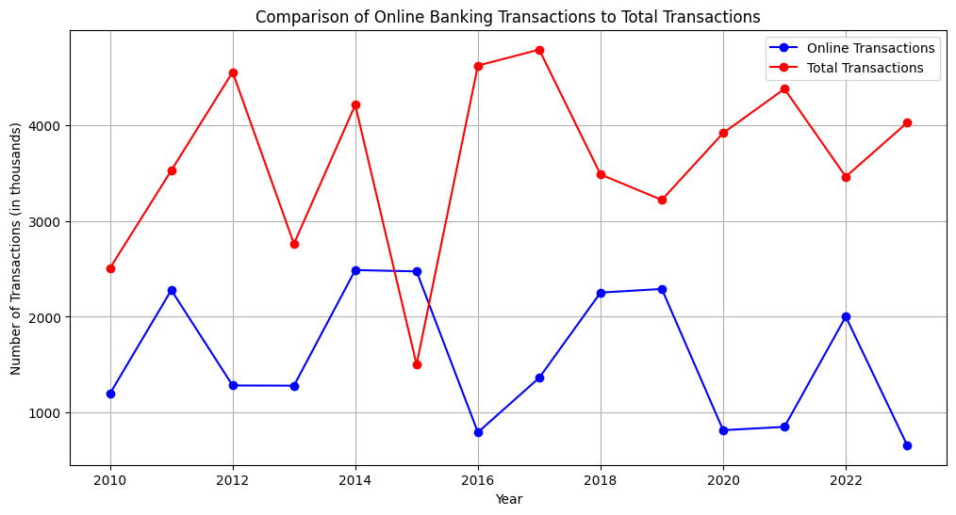**Inference:**

* This graph shows that online transactions constitute a significant portion of total banking transactions.
* The trend indicates a shift towards online banking as a preferred mode of transaction.
* Comparing both lines reveals periods where online banking adoption accelerated.

**Graph 4:** Adoption and Usage Frequency:

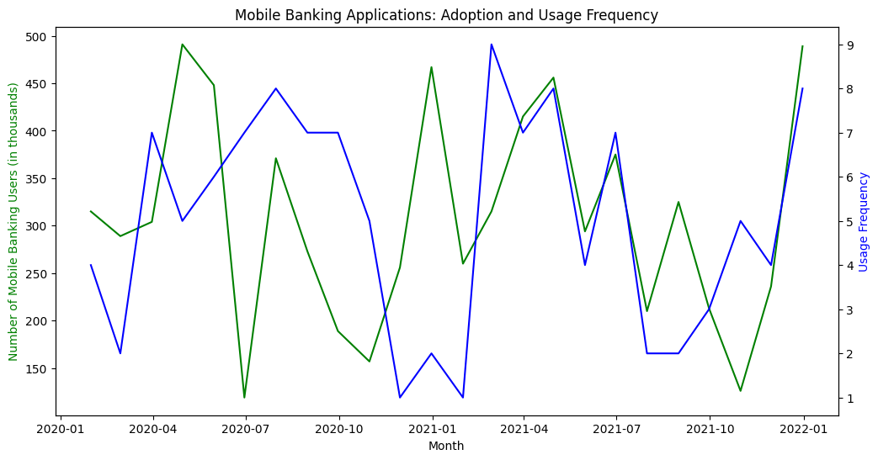

**Inference:**

* The dual-axis plot indicates a steady rise in mobile banking users alongside frequent usage.
* Peaks in usage frequency suggest periods of increased activity, possibly due to marketing campaigns or new app features.
* The overall upward trend highlights the growing importance of mobile banking.

**Graph 5:** Most Common Mobile Banking Activities:

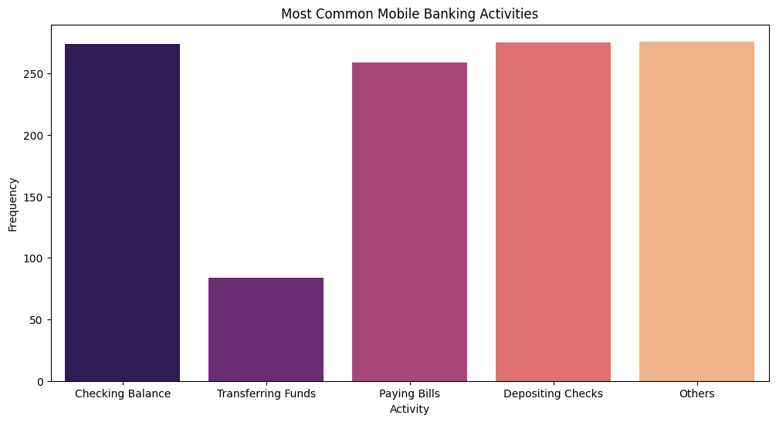**Inference:**

* Checking balances and transferring funds are the most frequent activities, reflecting primary user needs.
* Paying bills and depositing checks also show substantial usage, highlighting the multifunctionality of mobile apps.
* 'Others' category suggests potential for expanding or promoting lesser-known features.

**Graph 6:** Monthly Active Users (MAUs) vs Daily Active Users (DAUs):

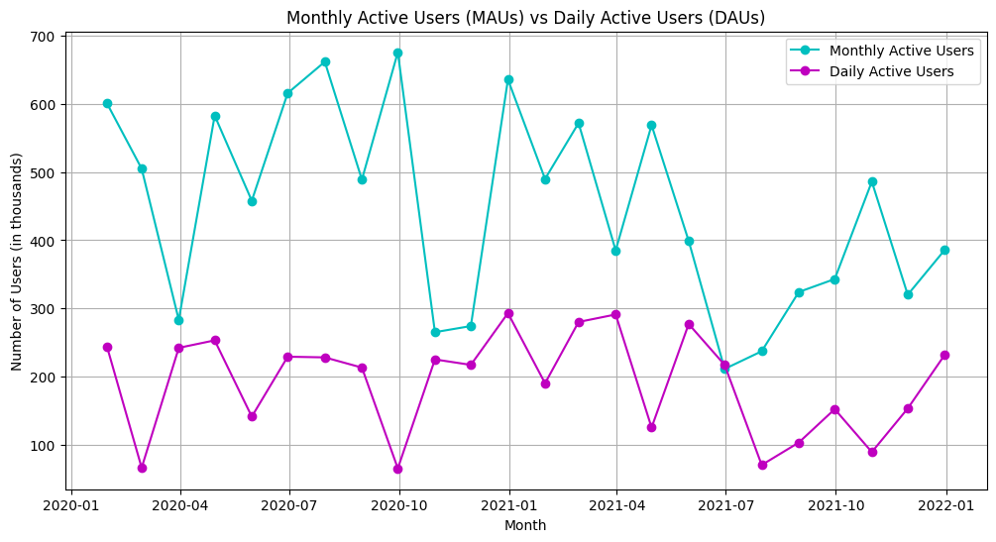**Inference:**

* The graph shows a consistent pattern of MAUs being higher than DAUs, as expected.
* The ratio between MAUs and DAUs can indicate the app’s engagement level; closer ratios suggest higher daily engagement.
* Analysing dips or peaks can provide insights into user behaviour and app performance.

**Graph 7:** User Satisfaction Scores for Different Voice Banking Services:

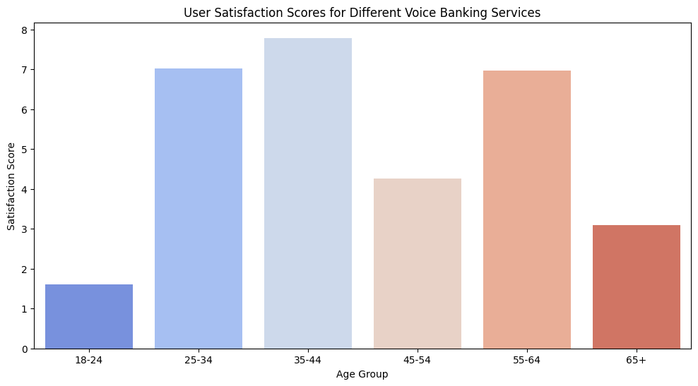

**Inference:**

* Satisfaction scores are relatively high across age groups, indicating general contentment with voice banking services.
* The highest satisfaction is seen in the 25-34 age group, possibly due to familiarity with technology.
* Slightly lower scores in older age groups suggest areas for improvement in user experience.

**Graph 8:** Adoption Rates of Voice Banking Services Across Different Income Groups:

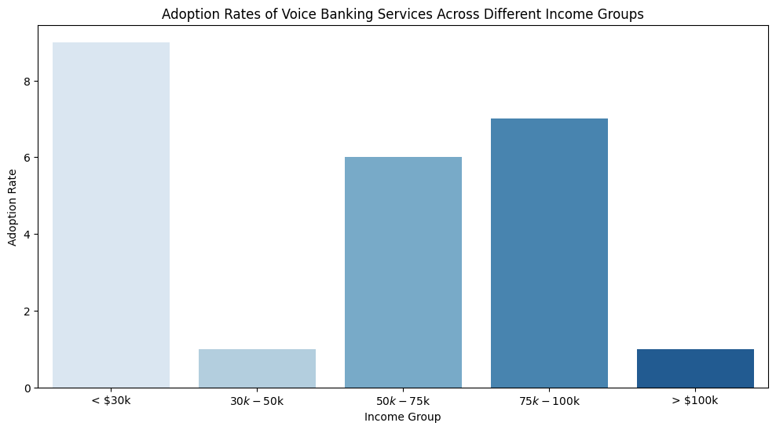**Inference:**

* The adoption rates are relatively even across income groups, with slightly higher rates in higher income brackets.
* This even distribution suggests that voice banking appeals to a broad audience regardless of income.
* Targeted marketing can help increase adoption in lower income groups.

**Graph 9:** Usage Frequency of Voice Banking Services by Time of Day:

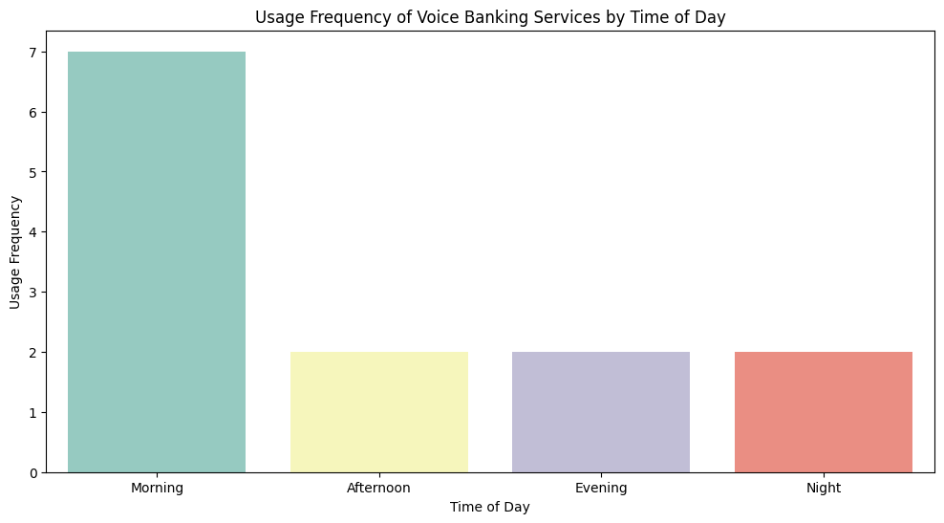**Inference:**

* Usage frequency is highest in the evening, indicating a preference for banking after typical working hours.
* Morning and afternoon also show significant usage, reflecting diverse user schedules.
* Understanding these patterns can help in optimizing service availability and support.

**Conclusion:**

The US banking sector has significantly transformed through the adoption of online banking services, mobile banking applications, and voice banking services, reflecting the broader trend of digitalization in the financial industry. Online banking services offer a wide range of functionalities, providing consumers with convenience and flexibility while allowing banks to reduce operational costs. Mobile banking applications enhance this convenience by enabling users to manage their finances from their smartphones with features like mobile check deposits and real-time notifications, driven by the growing dependence on smartphones. Voice banking services, the latest innovation, use artificial intelligence and natural language processing to facilitate hands-free banking, particularly benefiting visually impaired individuals and those seeking a seamless banking experience. These advancements underscore a shift towards digital banking, driven by consumer demand for convenience, accessibility, and enhanced security, ultimately improving customer satisfaction and positioning banks to compete better in an increasingly digital marketplace. As technology evolves, further innovations in digital banking are expected to continue transforming the US banking sector.